COMP 305 - Assignment 3



Version #0.1

All work Copyright © 2016 by Tardis Games.

All rights reserved.

Code licensed under the [GPL](https://github.com/aagavin/305-3D-Game/blob/feature/documentation/LICENSE)

Pedro Bento  
Aaron Fernandes

# Table of contents

Contents

Table of contents 2

Version History 3

Detailed Game Description 4

Controls 4

Interface Sketch 5

Screen Descriptions 5

Start Screen 5

Game play/Action Scene 6

End Scene 7

Character 7

Items 7

Enemies 7

Scoring 8

Sound Index 8

Art/Multimedia Index 8

Bonus Points: 10

# Version History

<https://github.com/aagavin/305-3D-Game/commits/develop>

Snapshot:

* b57469d - (9 hours ago) Merge pull request #54 from aagavin/hotfix/reenable-roof - Cheeseless (HEAD -> develop, origin/develop, origin/HEAD)

|\

| * 201bc56 - (9 hours ago) re enable roof that I turned off and never turned back on - Aaron

| * 663ebe5 - (9 hours ago) hotfix/reenable-roof - RBC Dev

|/

* 942baf8 - (19 hours ago) Merge pull request #53 from aagavin/feature/sound-index - Cheeseless

|\

| * 52a782f - (20 hours ago) soundtrack, documentation, heatgun fix - Aaron (origin/feature/sound-index, feature/sound-index)

| * 74c6fd7 - (23 hours ago) fixed missing part of florr - Aaron

|/

* 37b4ecd - (32 hours ago) Merge pull request #48 from aagavin/feature/cheeseissues - aagavin

|\

| * e88c823 - (32 hours ago) fixing merg conflicts - Fernandes, Aaron

| |\

| |/

|/|

* | 32bded9 - (2 days ago) Merge pull request #47 from aagavin/feature/documentation - Cheeseless

|\ \

| * | ff87695 - (2 days ago) some external documentation - Aaron (origin/feature/documentation, feature/documentation)

| * | c7b7454 - (2 days ago) added internal docs - Aaron

|/ /

| * a12e3bf - (2 days ago) Minimap added - Cheeseless

| * 5c80763 - (2 days ago) added deatiled game description - Cheeseless

| * 85bbdf2 - (2 days ago) made roof, made light not see roof - Cheeseless

|/

* 7bd82de - (3 days ago) Merge pull request #46 from aagavin/feature/gunheat - Cheeseless

|\

| * 4a88e8e - (3 days ago) add heat amo gun thing stuff. This closes issue # 45 - Aaron Fernandes

| * f3255f3 - (3 days ago) started some docs - Aaron Fernandes

|/

| * 6f62da9 - (3 days ago) Repositioned entire geometry - Cheeseless (origin/feature/roof)

|/

* 1323558 - (3 days ago) Merge pull request #44 from aagavin/feature/ui - Cheeseless

|\

| * caac7f0 - (3 days ago) pickups. This closes issue #39 - Aaron Fernandes

| * 02e5df2 - (3 days ago) added High score stuff. This should close #25 - Aaron Fernandes

| * c055562 - (4 days ago) Merge branch 'develop' of https://github.com/aagavin/305-3D-Game into feature/ui - Aaron Fernandes

| |\

| |/

|/|

* | 1644e0b - (4 days ago) Merge pull request #37 from aagavin/feature/explosound - aagavin

|\ \

| * | 98b56fc - (4 days ago) game over sound - Cheeseless (origin/feature/explosound)

| | * 26fe0d2 - (4 days ago) test - Aaron Fernandes

| |/

|/|

* | 9386de1 - (4 days ago) Merge pull request #36 from aagavin/feature/fire - Cheeseless

|\ \

**…**

# Detailed Game Description

This is a first-person arena survival shooter with a Dr. Who theme. The doctor has been trapped in a giant office with no exits, and is being attacked by an army of weakened clones of Daleks. The game is essentially a traditional high score seeking shooter where the intent of the player is to outlast as many waves as possible to attain a maximum score.

# Controls

The player will use the WASD keys to move the player. The mouse can be used to fire weapon and look around.

# Interface Sketch

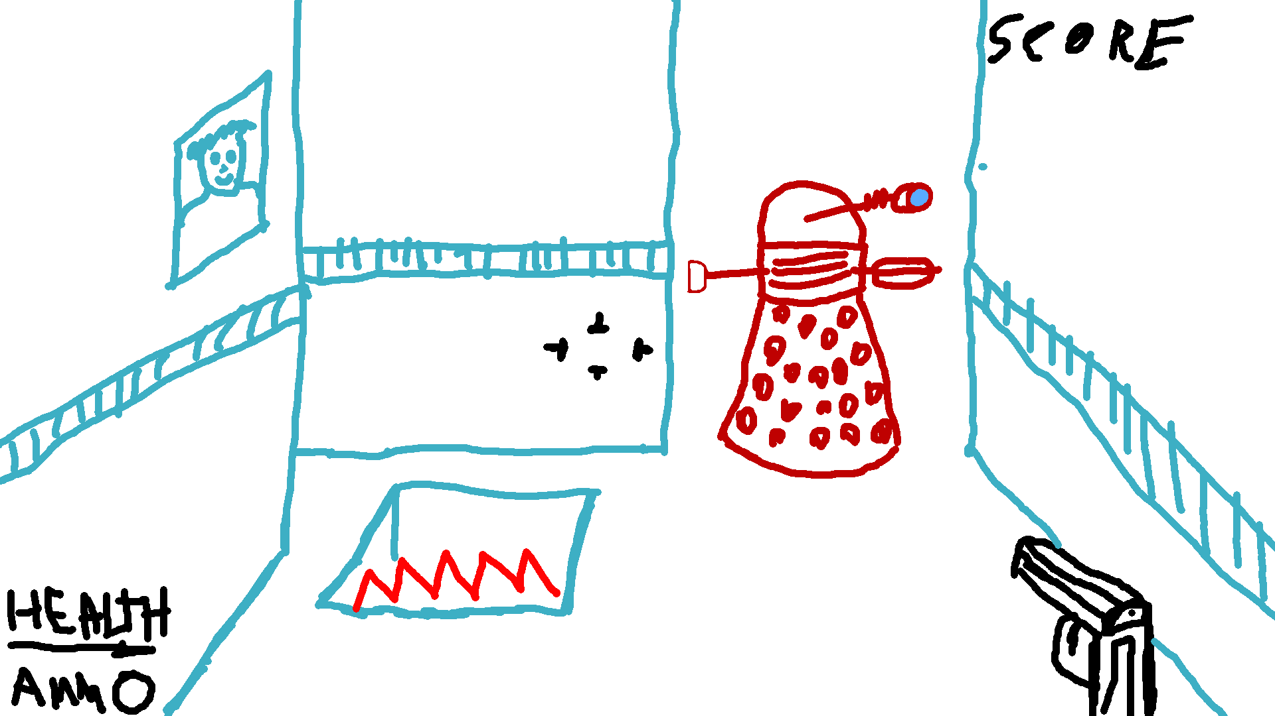

# Screen Descriptions

## Start Screen

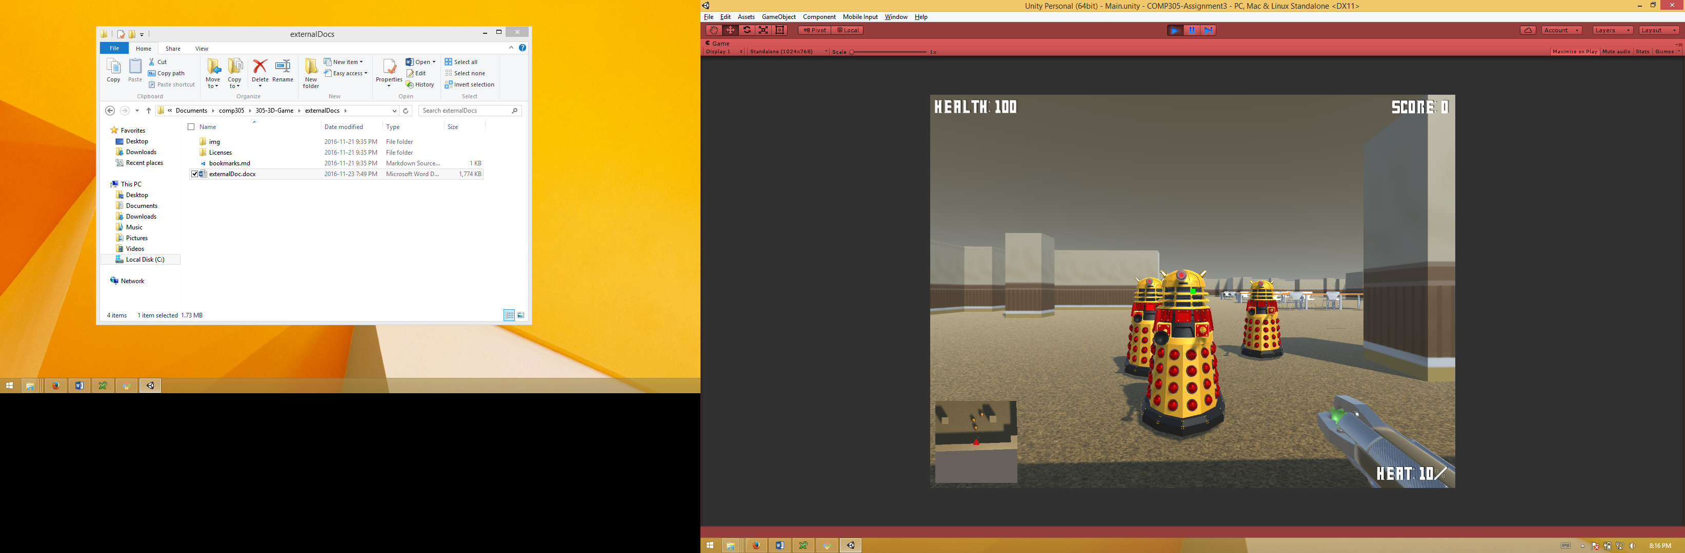

This is the start screen. Its shows the score hud, enimenies and wepon

## Game play/Action Scene

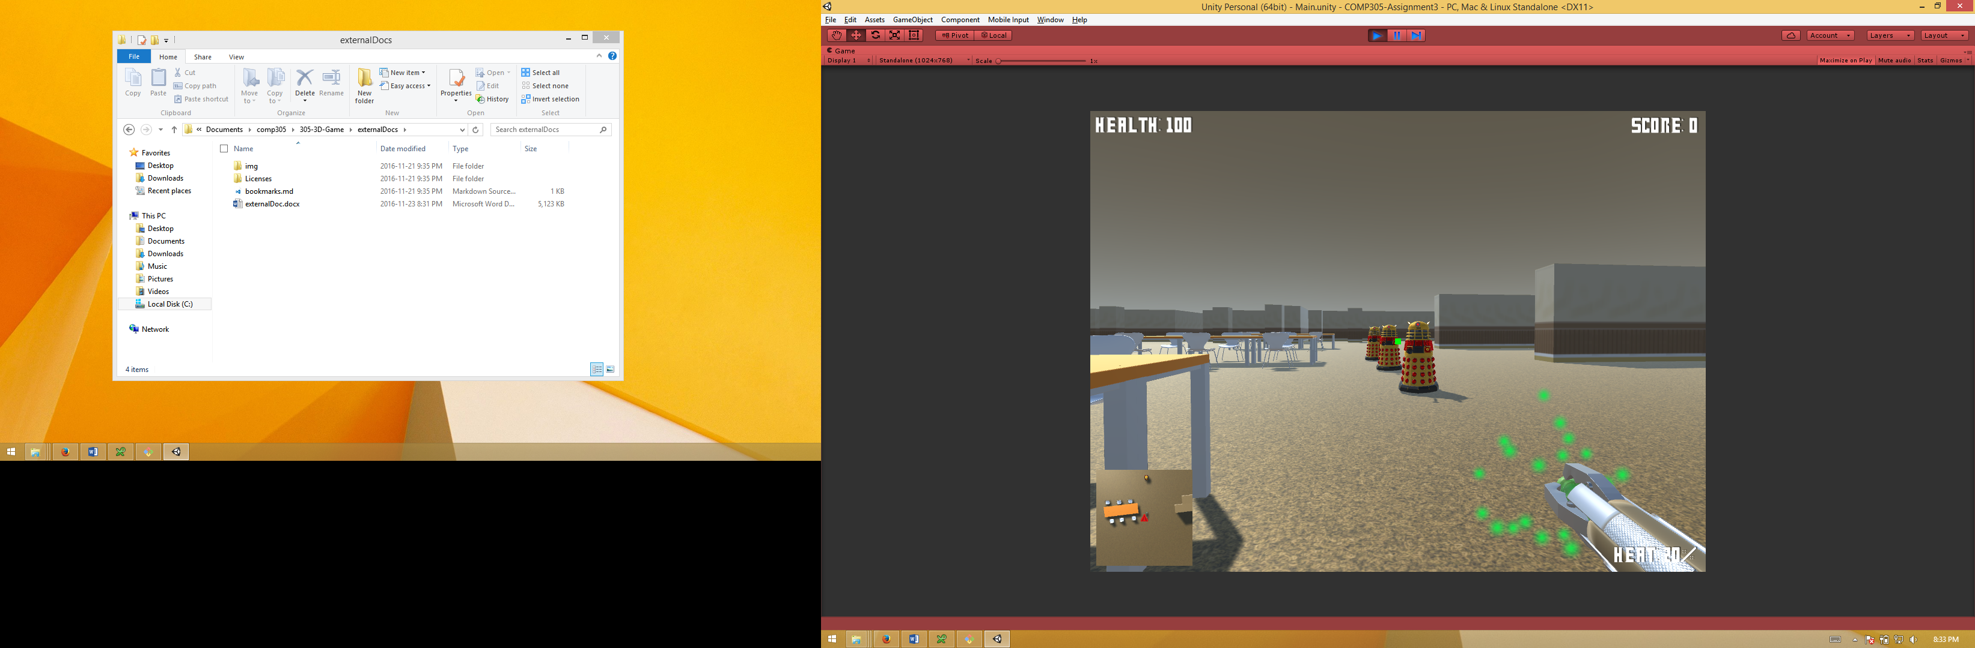

This is the action screen. It show the players wepon in action

## End Scene

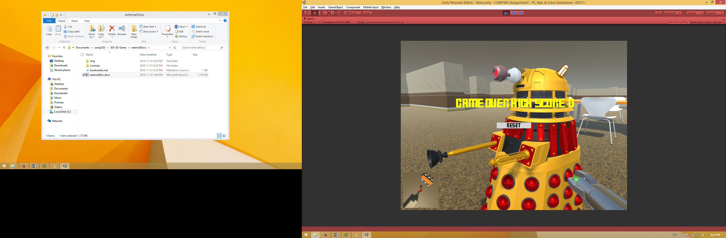

This is the end screen. When the players life reaches 0 they die and the game ends. The end screen will show there high score and allow the player to play again.

# Character

The Doctor has had his memory wiped so now he's an office worker. The player will use a sonic screwdriver the defeat the enemies described below.

# Items

The player can pick up heath packs that will appear at dalek spawn points forcing the player to go into danger to gain health. The health pickup will only appear when the player has less than 100 health. Picking up health only adds 5 to the health.

# Enemies

Enemies include daleks that have taken over the office. They will come in waves and attack the player until the player is dead.

# Scoring

The player needs uses a sonic screwdriver a defeat the enemies. The player gets 10 points for every enemy killed

# Sound Index

|  |  |  |
| --- | --- | --- |
| Sound Name | File | Source |
| Sonic Screwdriver | sonic screwdriver sound FX.mp3 | https://www.youtube.com/watch?v=yzZedNx2XOY |
| Health Pickup | health.wav | https://www.freesound.org/s/162387/ |
| Game Over | Game Over.mp3 | https://www.youtube.com/watch?v=o2b8-dfygVk |
| Explosion | Explosion.wav | Self-Created |
| Theme Sound | doctor who action theme.mp3 | https://www.youtube.com/watch?v=hmdj0uzOXtE |

# Art/Multimedia Index

|  |  |  |  |  |
| --- | --- | --- | --- | --- |
| Name | Art | Source | License & Author | |
| Sonic screwdriver |  | http://www.blendswap.com/blends/view/52144 | Creative Commons Zero (Public Domain)  Author: "11th doctors sonic screwdriver" by *otacon* |
| Office Furniture |  | http://www.blendswap.com/blends/view/44775 | Creative Commons Attribution 3.0  Author: "Alcas Office Partition Wall Systems" by *exedesign* |
| Dalek |  | http://www.blendswap.com/blends/view/52144 | Creative Commons Attribution 3.0  Author: "Dalek v1.0" by *Benjee10* |
| Health Pickup | http://www.blendswap.com/files/images/2012/03/blend_40445/metalix_alex_telford_gamecrate_medium_962a4020d10681557ded3cfa2fccfe188a98fd4a.jpg | http://www.blendswap.com/blends/view/40445 | Creative Commons Attribution 3.0  Author: "Low Poly Health Crate" by *Metalix* |

# Bonus Points:

These are extra features that we have added to the game and project:

1. Mini map

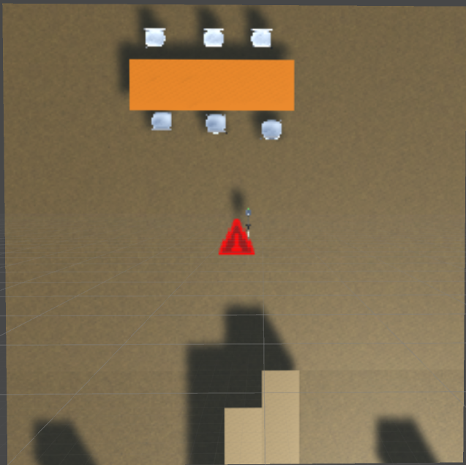

1. Soundtrack (doctor who action theme.mp3)
2. Proper GitHub and project management:
   1. Issue Tracking   
      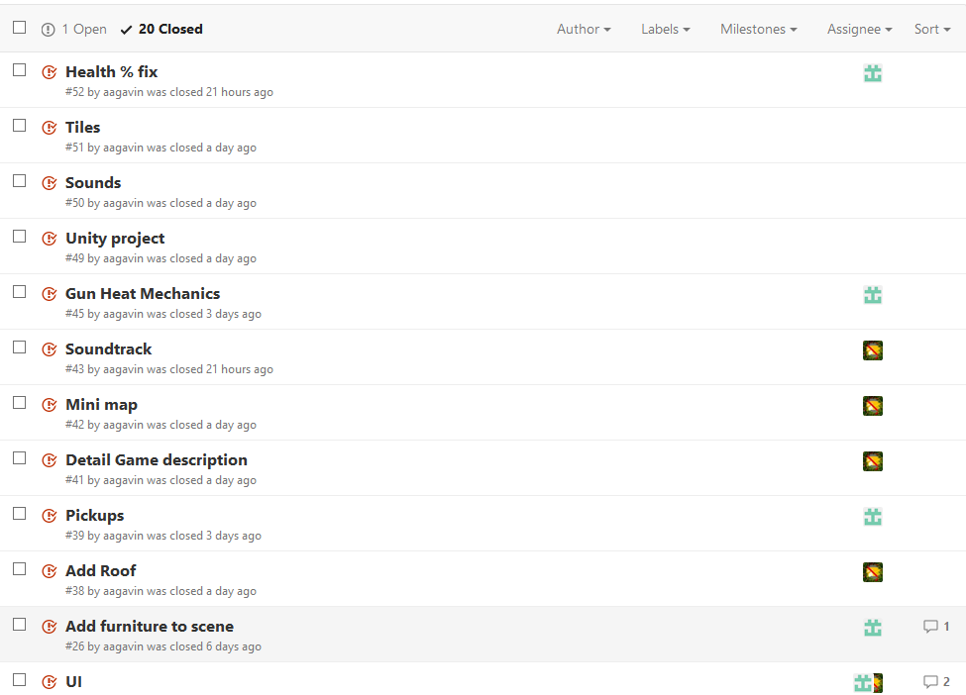

* 1. GIT Branching  
     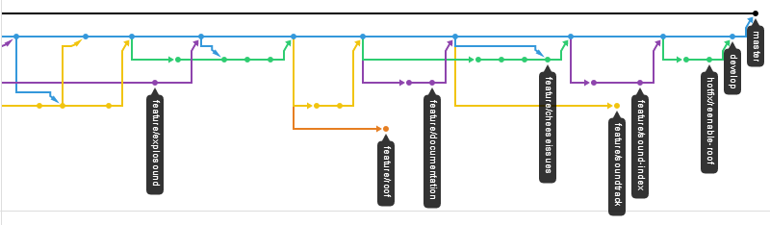
  2. GitHub Project Kanban chart  
     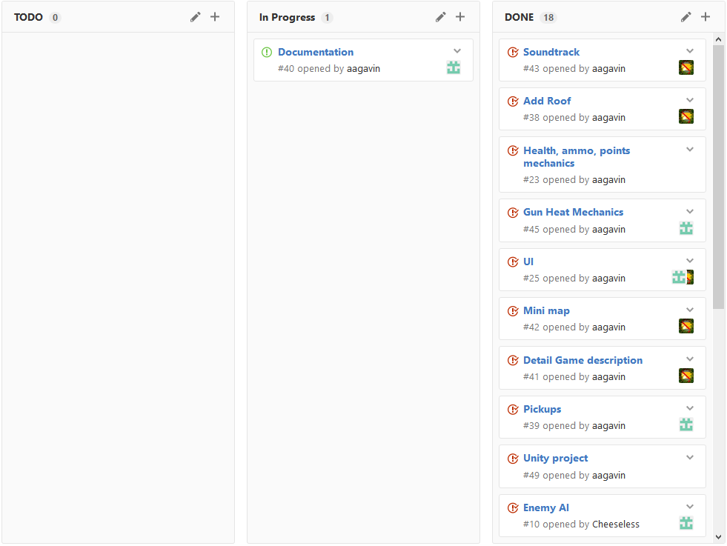
  3. Continuous Integration (Unity Cloud Build, for testing)  
     